NashTech_Testing Levels_Homework

1. 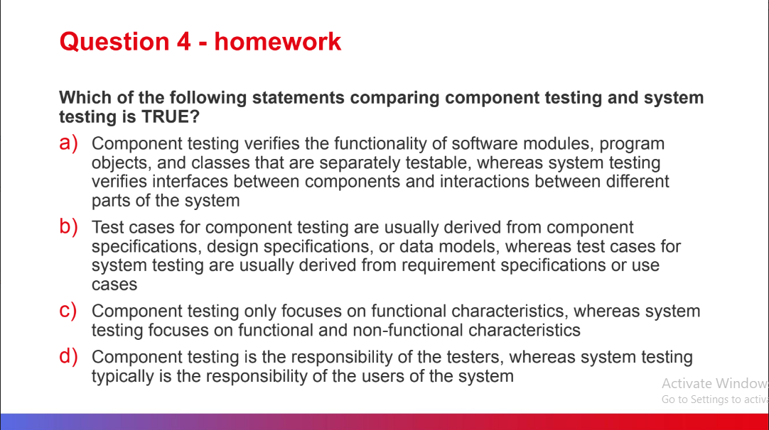

Answer: b) Test cases for component testing are usually derived from component specifications, design specifications, or data models, whereas test cases for system testing are usually derived from requirement specifications or use cases

2. 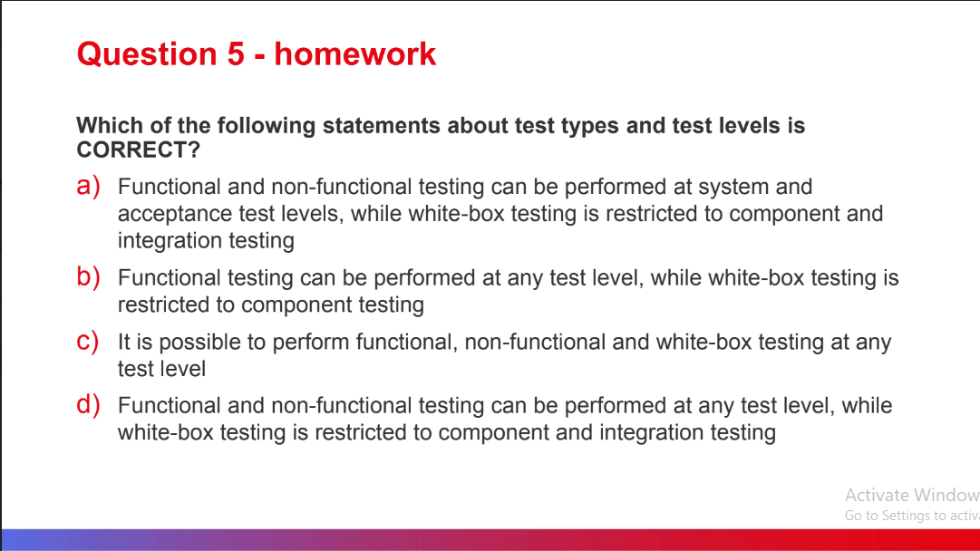

Answer: c) It is possible to perform functional, non-functional and white-box testing at any test level

3. 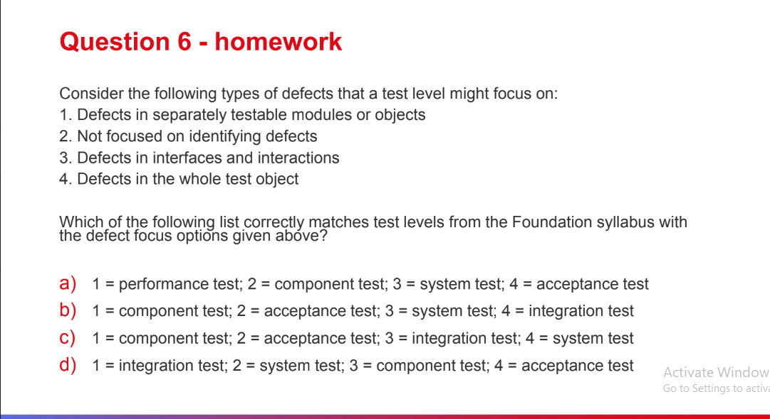

Answer: c) 1= component test; 2 = acceptance test; 3 = integration test; 4 = system test